**Project Report: Task Manager App**

**Introduction**

The Task Manager app is a powerful tool designed to help users efficiently organize and manage their tasks, streamline their daily workflow, and boost productivity. In this report, we will provide an in-depth overview of the app, highlighting its key features and benefits

**Splash Screen:**

At the start of the app, a captivating splash screen emerges, proudly presenting the app's distinctive logo and its name. The logo, with its modern design and thoughtfully chosen colors, immediately captures your attention, while the app's name, "Task Manager App" is prominently displayed alongside it. This dynamic duo on the splash screen sets the tone for your task management journey, blending visual appeal with a powerful and memorable identity.

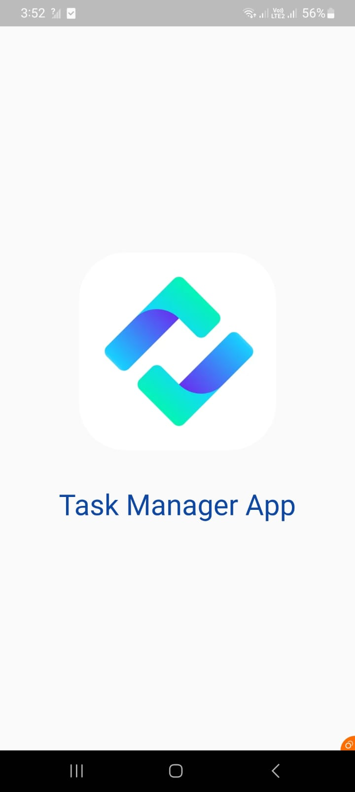

**Login Page:**

**Email Field:** Users are prompted to enter their username or email address. This information is used to uniquely identify them in the system.

**Password Field:** A secure password field is provided for users to enter their confidential passwords. Passwords are typically hidden as users type for security reasons.

**"Login" Button:** A prominent "Login" button allows users to submit their credentials and access their accounts. It's usually placed below the username/email and password fields.

**"Sign Up" or "Register" Link:** For users who don't have an account, there's typically a link that directs them to the registration or sign-up page. This link is often placed near the login button.

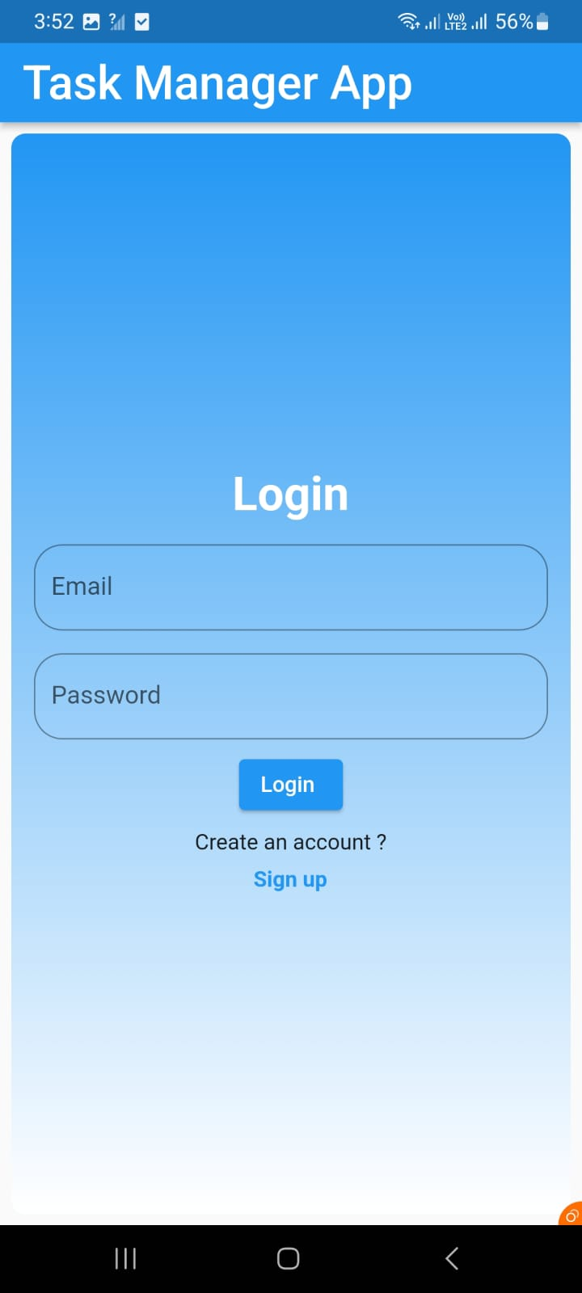

**Sign up:**

Full Name: Users provide their full legal name.

Email Address: A unique email address is required for account verification and communication.

Password: Users create a secure password, often with specific requirements.

Confirm Password: A field to re-enter the chosen password to ensure accuracy.

"Sign Up" Button: A prominent "Sign Up" or "Create Account" button is displayed, allowing users to submit their registration information and create their accounts.

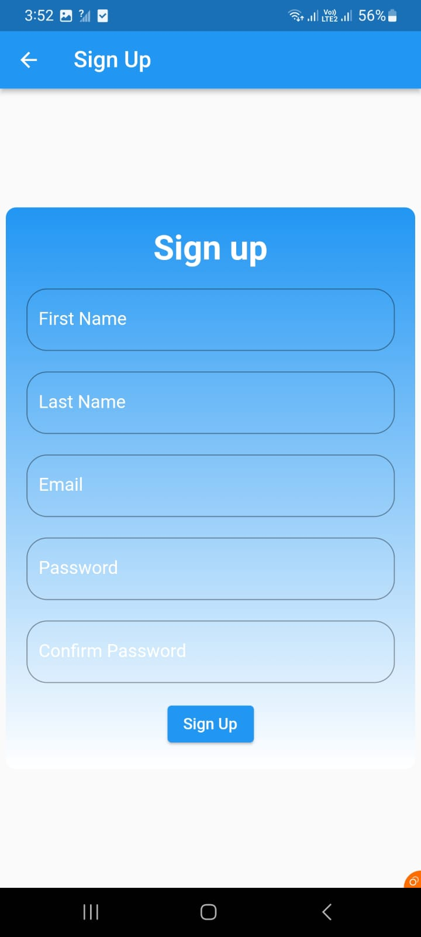

**Main Screen Overview:**

The main screen of a Task Manager app is the central hub where users can add, view, and manage their tasks efficiently. The "Edit" and "Delete" buttons allow users to make changes or remove tasks as needed, while the overall layout and features aim to provide a seamless and productive task management experience.

**Task List:** The main screen displays a list of tasks that users have added. Each task entry typically includes the following information:

**Title:** The title of the task, which briefly describes what needs to be done.

**Description:** A brief or detailed description of the task, providing additional context if necessary.

**Time:** The time associated with the task

**Due Date:** The date by which the task should be completed or its deadline.

**Add Task Button:** A prominent "Add Task" button is usually located at the top of the screen. When clicked, this button opens a form for users to enter details for a new task.

**Edit Button**: For each task entry, there is typically an "Edit" button or icon (e.g., a pencil icon) that allows users to modify the task's title, description, time, and due date. Clicking the "Edit" button opens a task editing interface.

**Delete Button:** Similarly, for each task entry, there is often a "Delete" button or icon (e.g., a trash can icon) that enables users to remove a task from their list.

**Firebase:**

Task Manager app using Firebase, user registration involves collecting user details via a registration form and creating a new user account with Firebase Authentication. After successful registration, additional user data, such as name email,password information, can be stored in Firebase's Firestore Database. When a user logs in, Firebase Authentication verifies their credentials, granting access if they are correct. The app can then retrieve the user's data from the database and display it on relevant app sections. This process ensures that user-specific task data and profiles are securely managed and accessible upon login**.**

**Challenges Faced**: During the development of the Task Manager app, several challenges were encountered. These challenges included ensuring user authentication and authorization, and designing an intuitive user interface. Overcoming these challenges required careful planning to create a robust and user-friendly application**.**

**Future Improvements:** There are several areas for future improvements in the Task Manager app. These include enhancing data backup and recovery options, implementing more advanced task sorting and filtering features, expanding platform support to reach a wider user base, and refining the user experience through user feedback and usability studies. Additionally, exploring integration with other productivity tools and services could further enhance the app's capabilities and value.

**Conclusion:**

we discussed various aspects of a Task Manager app, from its splash screen to its main screen, registration and login processes, and integration with Firebase. We explored the key features, functionalities, and best practices for designing and developing such an app. Additionally, we touched on challenges faced during development, potential future improvements, and the overall significance of a Task Manager app in enhancing productivity and organization for users and also provide insights into both the technical and user experience aspects of creating an effective task management solution.

**Team Members:**

**Asad Ali - 20SW042**

**Awais Shiekh – 20SW048**